|  |  |
| --- | --- |
| EXP NO: 6(A) | Installation of HBase, Installing thrift along with Practice examples |
|  |
| DATE: |  |

**AIM: -**

**BACKGROUND THEORY: -**

# **PROCEDURE: -**

* Switch to superuser mode using sudo su.
* Update all system packages to ensure you have the latest versions.
* Install wget to download files from the internet.
* Use wget to download the HBase binary tarball from the official website.
* Extract the HBase binary tarball using the tar command.
* Move the extracted HBase directory to /usr/local/hbase for proper management.
* Open the .bashrc file to set the necessary environment variables for HBase.
* After editing the .bashrc file, apply the changes by sourcing it.
* Navigate to the HBase configuration directory.
* Open and edit the hbase-env.sh file to configure the environment variables for HBase.
* Open the hbase-site.xml file to configure HBase's storage mode.
* Finally, start the HBase services using the following command.
* You can verify if HBase has started correctly by running the HBase shell

# **CODING: -**

* sudo su
* **Update the system**
  + sudo yum update -y
* **Install wget**
  + sudo yum install wget -y
* **Download HBase**
  + wget <https://downloads.apache.org/hbase/2.4.15/hbase-2.4.15-bin.tar.gz>
* **Extract the HBase tarball**
  + tar -xzvf hbase-2.4.15-bin.tar.gz
* **Move to root directory**
  + sudo mv hbase-2.4.15 /usr/local/hbase
* **Configure Hbase Environment Variables**
  + nano ~/.bashrc
  + Add the following in that file as #HBase Variables
    - export HBASE_HOME=/usr/local/hbase
    - export PATH=$PATH:$HBASE_HOME/bin
    - export JAVA_HOME=/usr/lib/jvm/java-1.8.0source ~/.bashrc
  + source ~/.bashrc
* **Configure HBase**
  + cd /usr/local/hbase/conf
  + sudo nano hbase-env.sh
  + export JAVA_HOME=/usr/lib/jvm/java-1.8.0
* **Configure HBase storage mode**
  + sudo nano hbase-site.xml
    - <configuration>
    - <property>
    - <name>hbase.rootdir</name>
    - <value>file:///usr/local/hbase/data</value>
    - </property>
    - <property>
    - <name>hbase.zookeeper.property.dataDir</name>
    - <value>/usr/local/hbase/zookeeper</value>
    - </property>
    - </configuration>
* start-hbase.sh

# **OUTPUT: -**

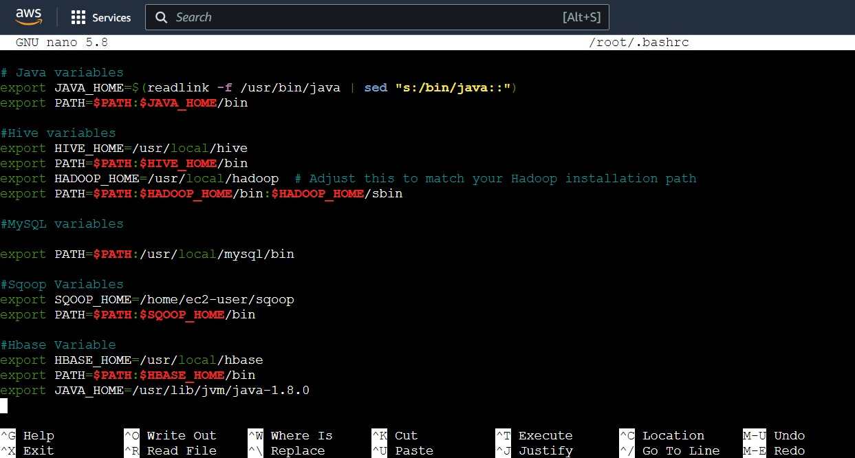

# How To Install HBase on Ubuntu (HBase Installation)